Calculation of true length of roof members

It is important to calculate the dimension of the true length of a roof member. These dimensions are important to determine the accurate span of rafter, overhang, underpurlins, fanstruts etc.

The most appropriate method to do this is using trigonometrical ratios, like sin, cos, tan of an angle. The ratio for sin and cos range between 0 and 1.

sin 0° = 0 and cos 0° = 1 and
sin 90° = 1 and cos 90° = 0

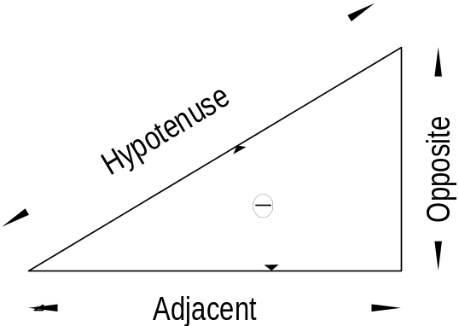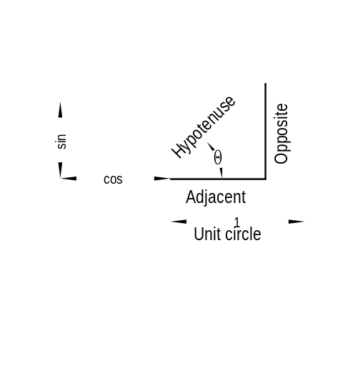Look at the unit circle shown in figure 1 (a). The sin (cos) of an angle is the relationship of the vertical and horizontal component of the given angle. We are using the right angle triangle, shown in figure 1 (b), to calculate the sides of a right angle triangle.

(a) (b)

Figure 1

As can be seen the hypotenuse is always the longest side and is opposite the right angle. The other two sites are referring to the given angle of the triangle. The given angle here is Θ (theta), and close to angle Θ is the adjacent side found, whereas the opposite side is opposite the angle Θ.
Consider the triangle above in this figure the adjacent side refers to the horizontal dimension (rafter run) of the building which are usually given. The hypotenuse on the other hand refers to the true length of the rafter that we have to determine, and the angle refers to the roof pitch.

Example
Find the true length of the rafter.
According to the timber framing code AS 1684 – 1999 we need to know the definition of span and spacing.

Span the face-to-face distance between points giving full support to structural timber members or assemblies.
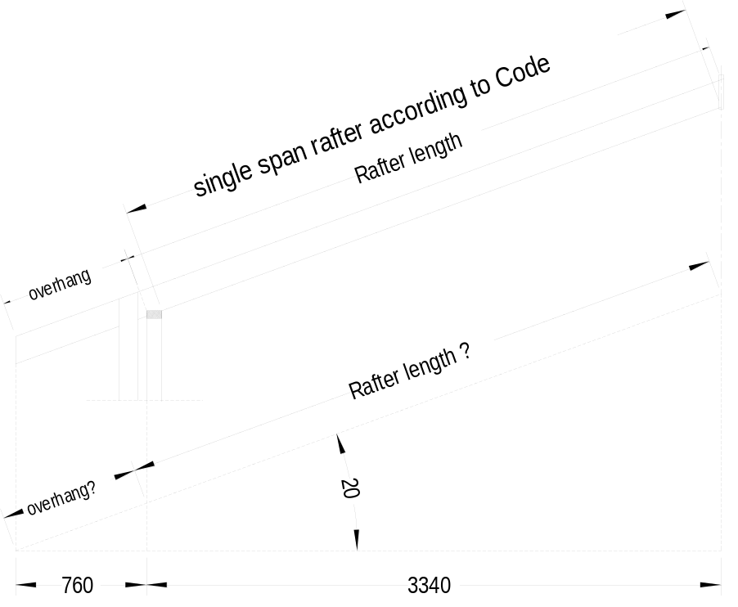Spacing the centre-to-centre distance apart from structural timber members.

Figure 2
As can be seen the span of the rafter in the figure below is not quite in agreement with the code but we will use the rafter length as the rafter span in this subject. The safety margin is 120 mm with a rafter depth of 100 mm and increases to approximately 140 mm with a rafter depth of 150.
The angle  will be the roof pitch
The opposite site is the rise of the roof
The adjacent side is the rafter run
The hypotenuse is the true length of the rafter

In our example the roof pitch is 20°, and the rafter run is 3.340 metre.
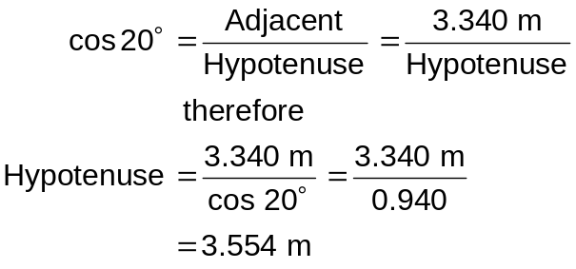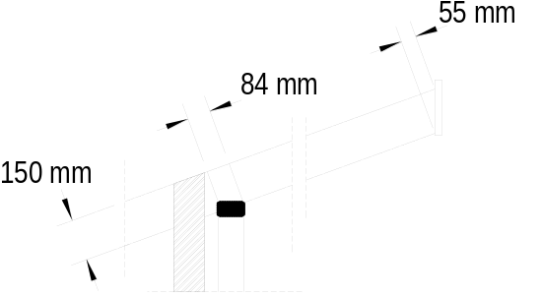
Figure 3

Therefore the true length of the rafter is 3.554 metre.
Please remember that the rafter span according to the Code is the face-to-face distance and that our calculated distance accommodates a safety margin.

Now we have to find the eaves overhang.

Look also at Figure 5.9 Section 5 in AS1684 - 1992 regarding the length of the overhang.
The overhang is 600 mm plus the 110 mm brickwall plus the 50 mm cavity which equals 760 mm.
Now we repeat the same procedure as above (the overhang is in this case the Hypotenuse).
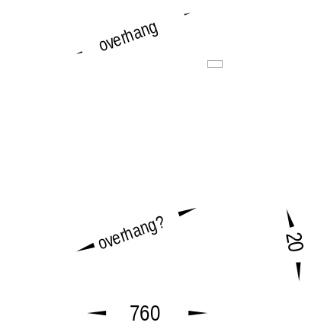
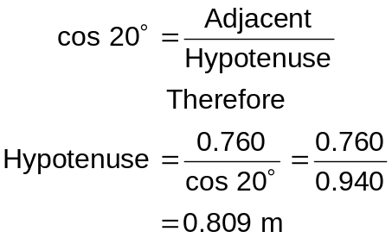
The eaves overhang for a brick veneer building with 600 mm eaves width is 0.809 metre
Figure 4

Find the length of a strut
If a rafter is supported on to points only and an appropriate size can not be found in the tables. an additional support (underpurlin) is needed. The underpurlin must be supported by struts.
Struts may be arranged vertically as shown in figure 5 or perpendicular to the rafter as shown in figure 6.
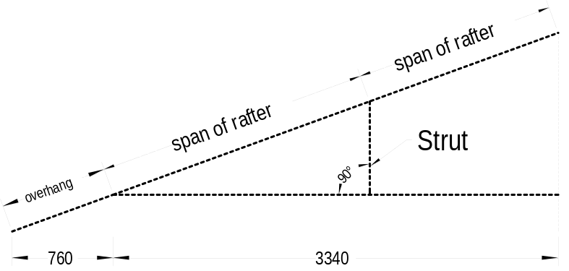
Figure 5

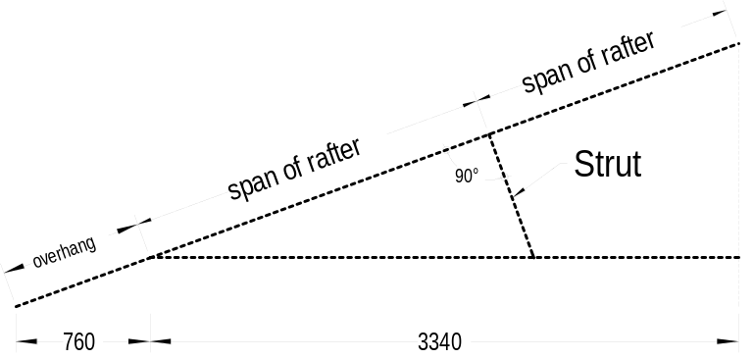

Figure 6

The position of the underpurlin must be determined before we can calculate the length of the strut. To utilise the continuous span of a rafter the position of the underpulin must be in the middle one-third of the rafter as shown in figure 7. Remember that continuous span member is a member whereby one span does not exceed another by more than one-sixth (Section 1, Rule 1.4.9).
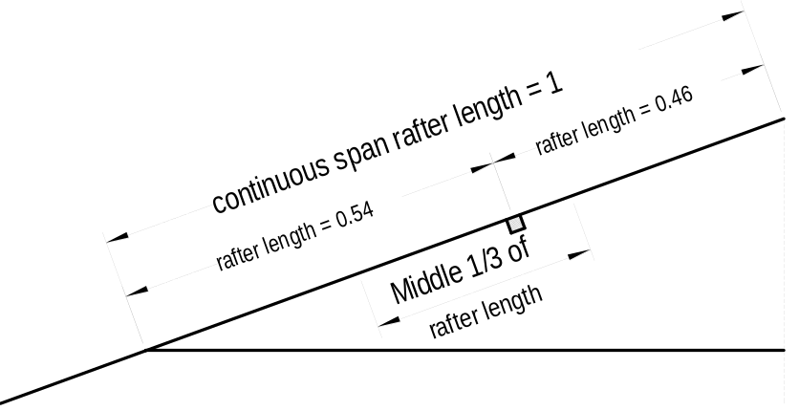
Figure 7

Look in figure 5 and 6 above. We can calculate the length of the vertical strut using sin or cos but we cannot directly calculate the length of the strut perpendicular to the rafter as shown in 6. To avoid a tedious calculation (finding hypotenuse first and then the opposite side) we should use the tan function to calculate the strut directly.
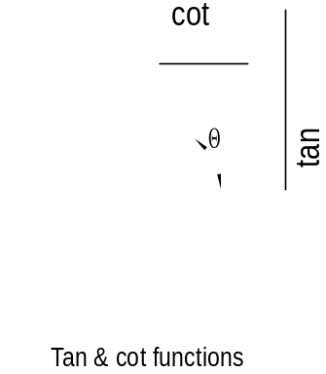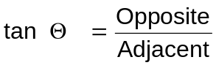
Again the tan of an angle is
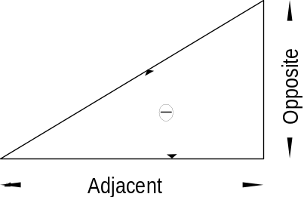

Figure 8
As can be seen from the unit circle the tan and cot can be any number from ½° (0.0087) to 89.9° (572.95). The angle  shown in the diagram is actual 55° and tan 55° is 1.428 and cot 55° 0.700.
The position of the underpurlin must be fixed before we can calculate the strut length. To calculate the vertical strut we use the tan-function. The adjacent site (½ of the building side) is known from previous calculation, it is 3.34 m. If we position the underpurlin as shown on figure 7 then the rafter span (which is the hypotenuse) is 3.554 × 0.54 = 1.919 metre.

Therefore the length of the vertical strut is

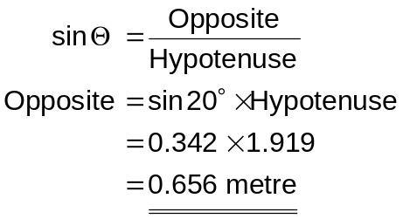

The rafter length for a perpendicular strut is the same as before 1.919 metre but this figure refers now to the adjacent side of the right angle triangle. The hypotenuse is not given and we do not need this dimension at the moment.

The length of the perpendicular strut is therefore
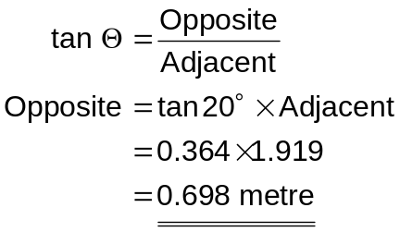
The span of an underurlin can be reduced if a fan-strut is used instead of a single strut. Paragraph 5.3.11 in As 1684 – 1992 stipulates that the angle of a fan-strut should not exceed 45°. (A single strut should not exceed 30° from the vertical)

To reduce the span of an underpurlin effectively the fan strut should have an angle of 45° because this results in a maximum spread of the fan strut.

Find the spread of a fan strut.
Geometrically the fan strut consists of two isosceles right angle triangles as shown in figure 9. As both angles are the same therefore both sides must be the same. Check on your calculator the sin of 45° (= 0,707) and cos 45° (= 0.707) and you will see that you will get equal figure for both (sin and cos).

The same refers to tan and cot. Tan 45° equals cot 45° and this figure is one; see also unit circle in figure 8. Check on your calculator tan 45° (= 1) and cot 45° (= 1). Cot is often not found on calculators because of the relationship between the functions, as these are
sin α = cos (90° - α) cos β = sin (90° - β)
tan φ = cot (90° - φ) cot θ = tan (90° - θ)

In our previous calculation we found the length of the vertical strut 0.656 m and the length of the perpendicular strut 0.696 m
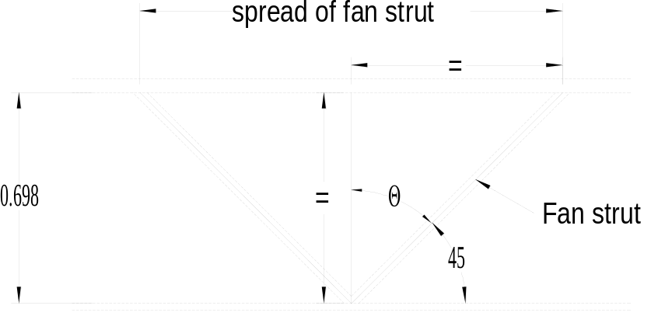

Figure 9

The spread of a vertical fan strut is therefore 0.656 × 2 = 1.312 m
and
The spread of a perpendicular fan strut is therefore 0.696 × 2 = 1.392 m

The relation ship between the angle of a triangle and the sides of it is:

